MAP Visualization

plotmap <- ggplot()+

geom_polygon(data = final.plot,aes(x = long, y = lat, group = group, fill = Count),

color = "black", size = 0.25) +

coord_map()

plotmap

This will be the map shown after running the above code.

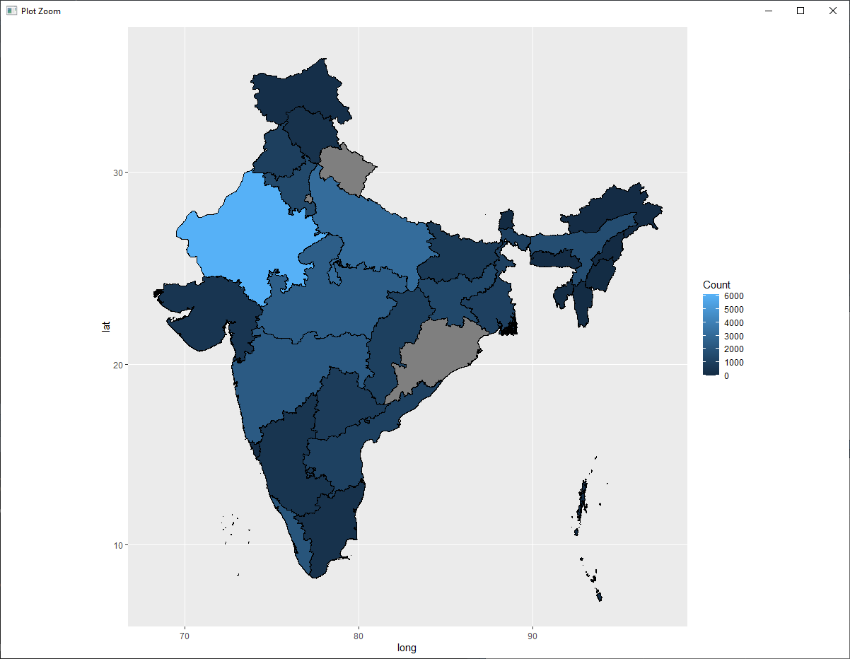

#plot with different color

ggplot()+

geom_polygon(data = final.plot, aes(x = long, y = lat, group = group, fill = Count),

color = "white", size = 0.25) +

coord_map()+

scale_fill_distiller(name = "Total Victims(2019)", palette = "Reds") +

labs( x = NULL,

y = NULL,

title="Crime Rate - Victims of Rape Report 2019")

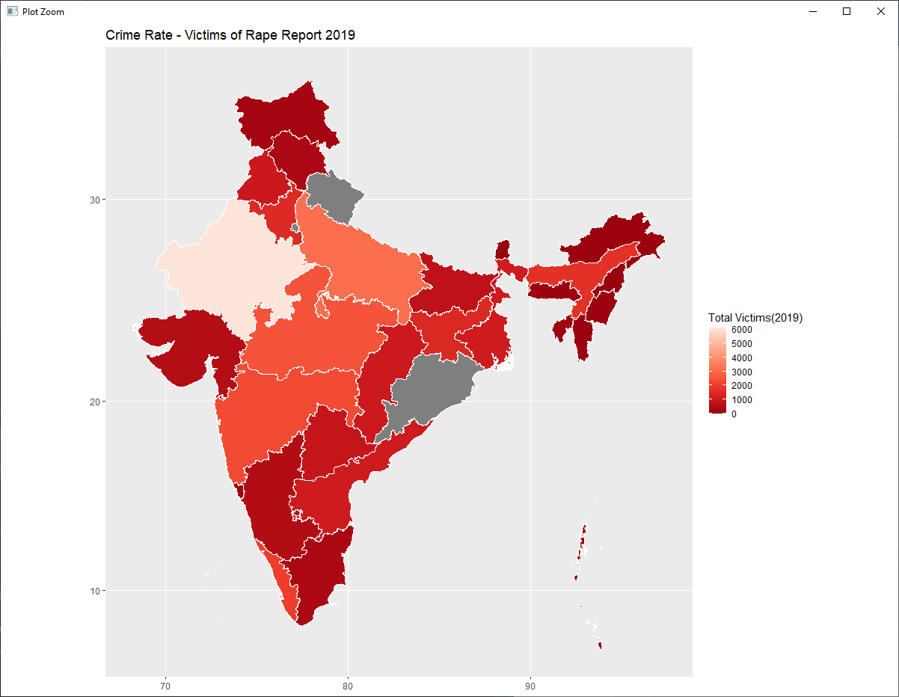

# Changed the limit, - see the color palette (dark are most cases of crime reported, less color has less number of crime reported.)

ggplot()+

geom_polygon(data = final.plot, aes(x = long, y = lat, group = group, fill = Count),

color = "white", size = 0.25) +

coord_map()+

scale_fill_distiller(name = "Total Victims(2019)", palette = "Oranges", direction = 1)+

labs( x = NULL,

y = NULL,

title="Crime Rate - Victims of Rape Report 2019")

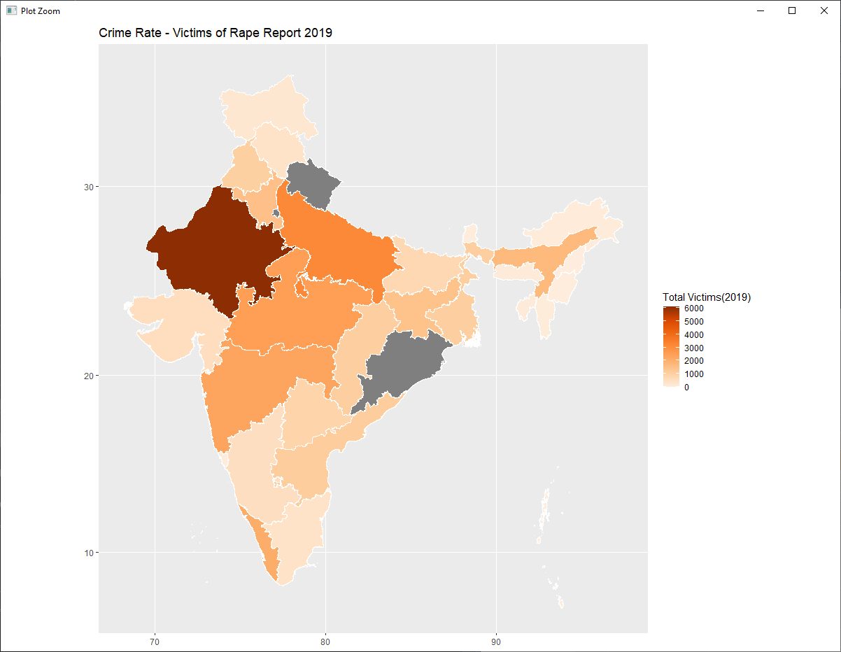

# With state names

cnames <- aggregate(cbind(long, lat) ~ id, data=final.plot, FUN=function(x) mean(range(x))) # for aggregating the state names in map

ggplot()+

geom_polygon(data = final.plot, aes(x = long, y = lat, group = group, fill = Count),

color = "white", size = 0.25) +

coord_map()+

scale_fill_distiller(name = "Total Victims(2019)", palette = "Oranges", direction = 1)+

labs( x = NULL,

y = NULL,

title="Crime Rate - Victims of Rape Report 2019")+

geom_text(data = cnames, aes(long, lat, label = id), size=2, fontface="bold")+

theme_dark()

